App Server and Web server day 6
- Install nginx and run nginx on port number 81.
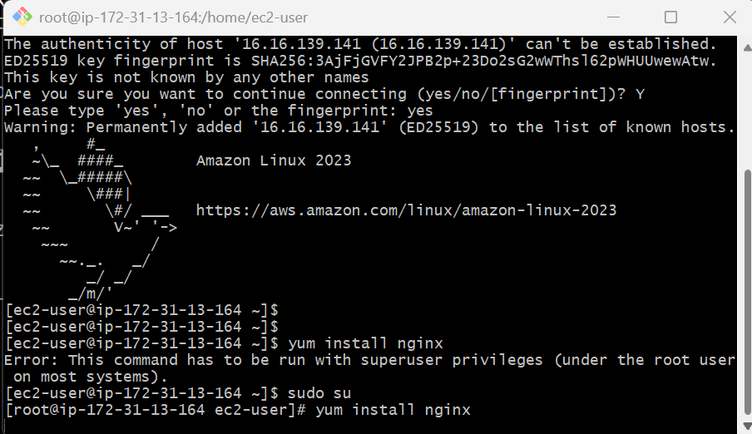
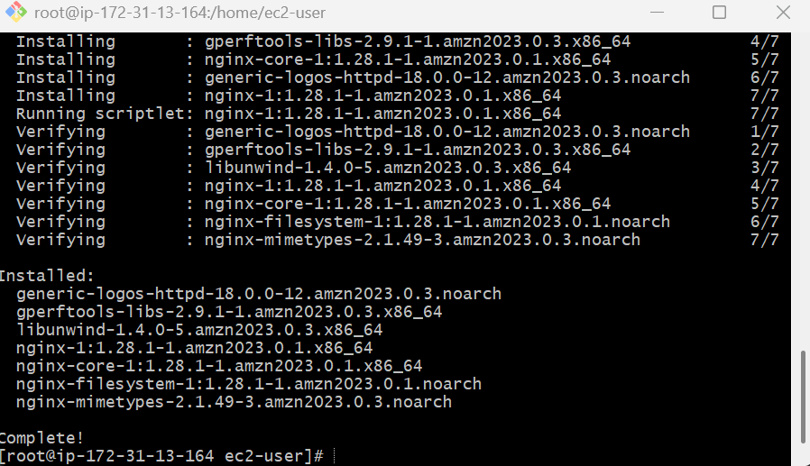
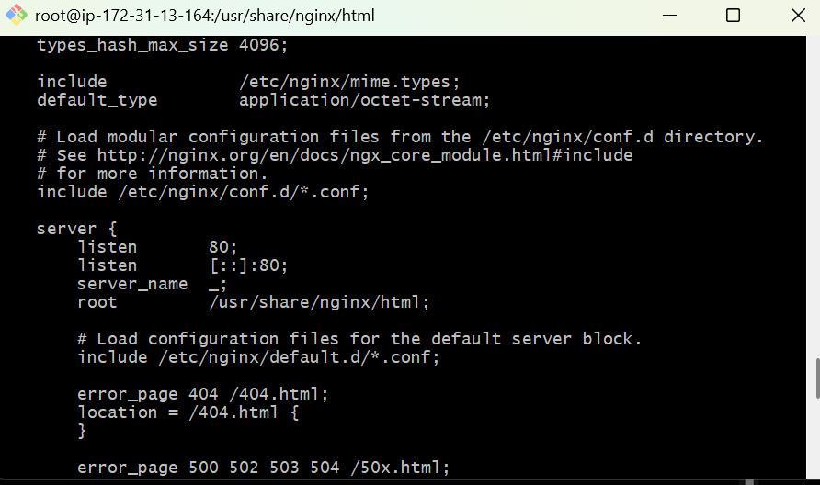

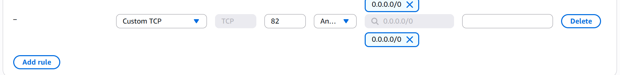
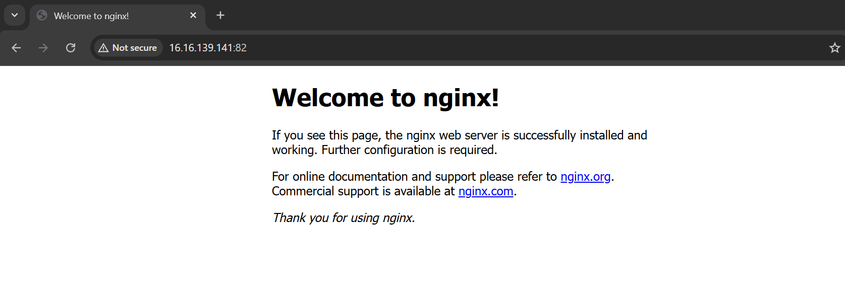
- Deploy a sample index.html file on nginx.
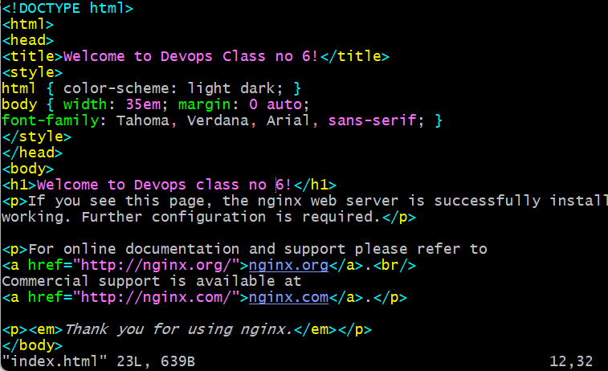
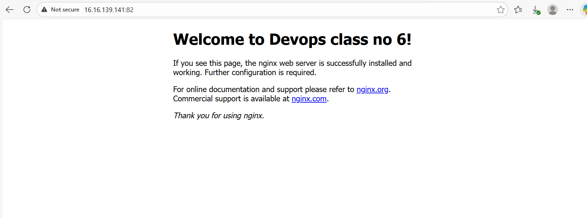
- Install Apache and run Apache on port number 82
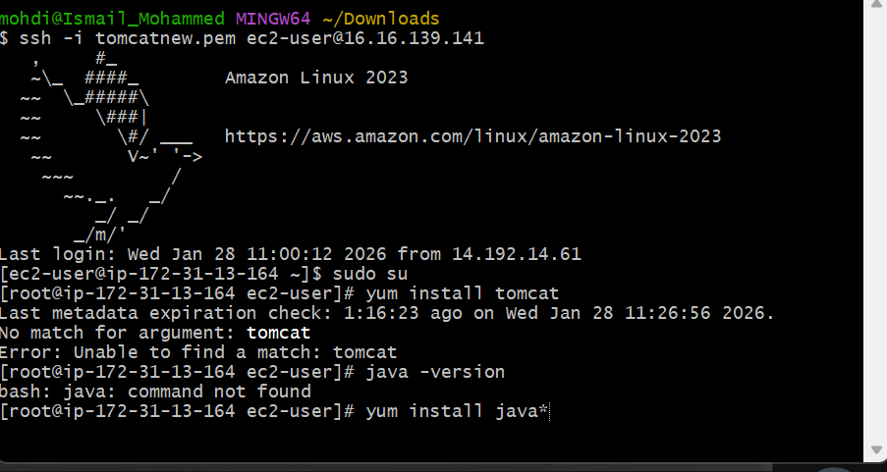
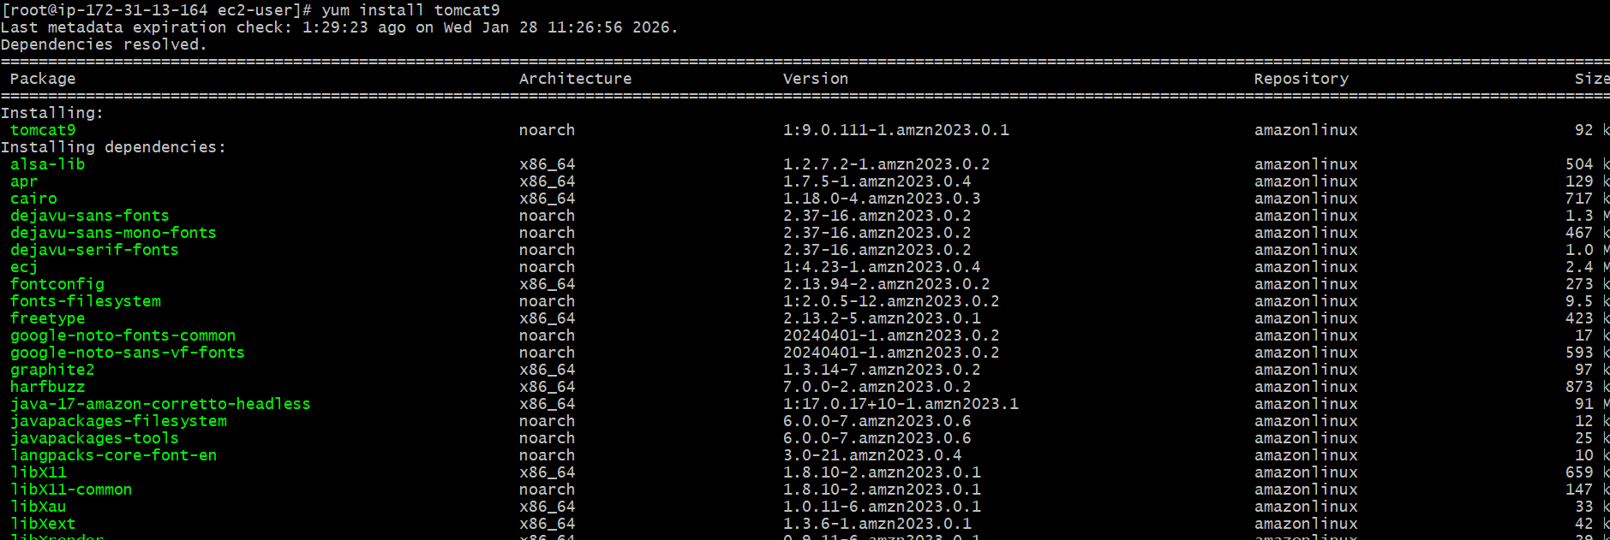
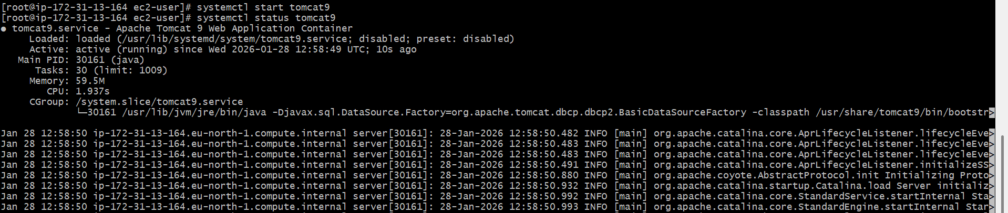
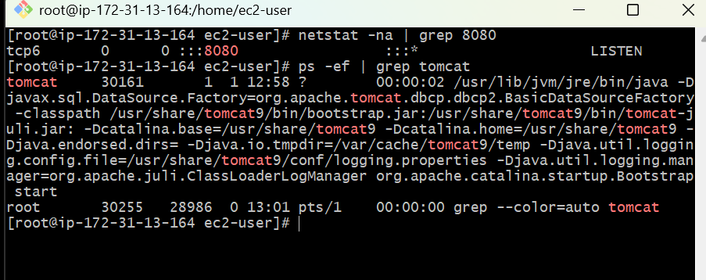
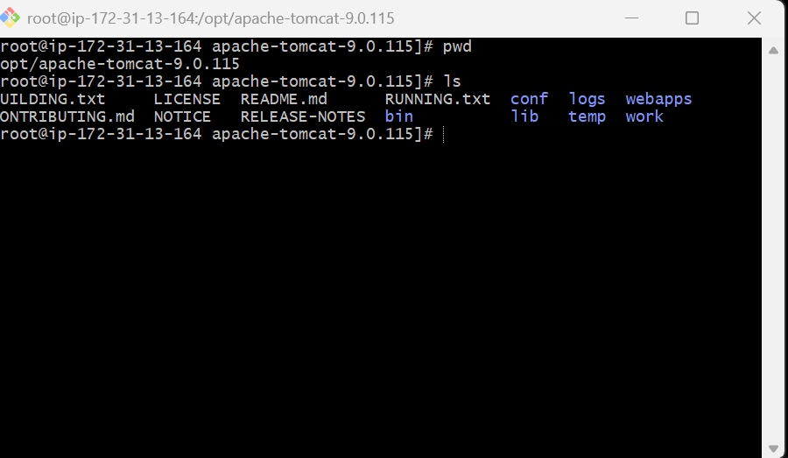
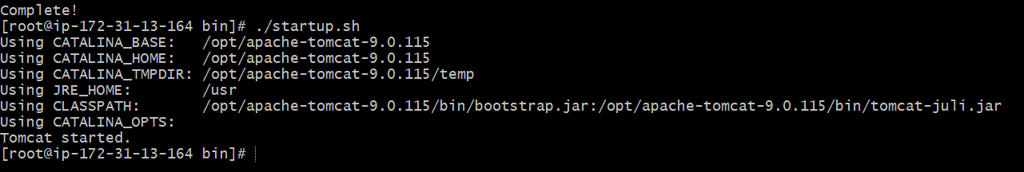
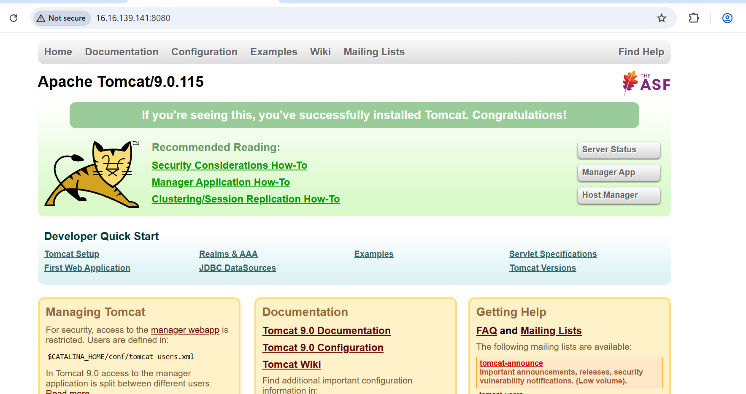
- Deploy a sample index.html file on Apache.
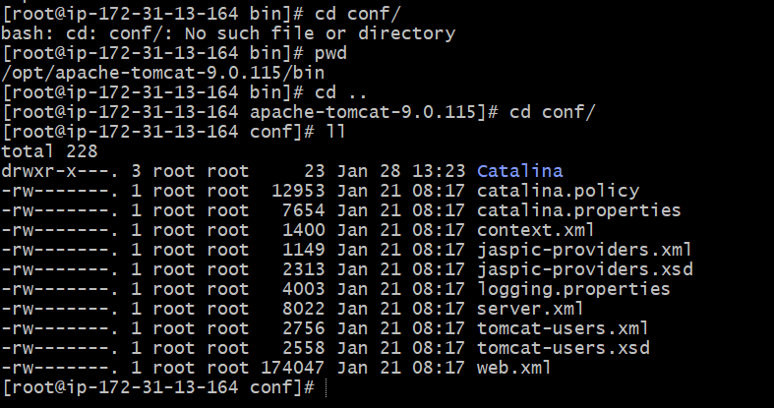

- Install Apache tomcat on port number 8082

Change the port no
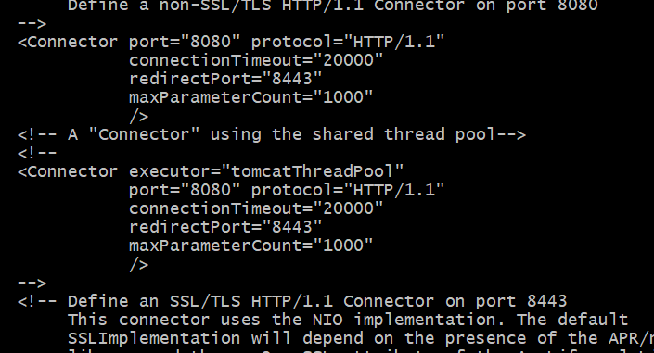
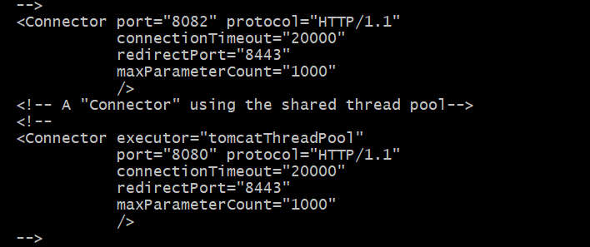
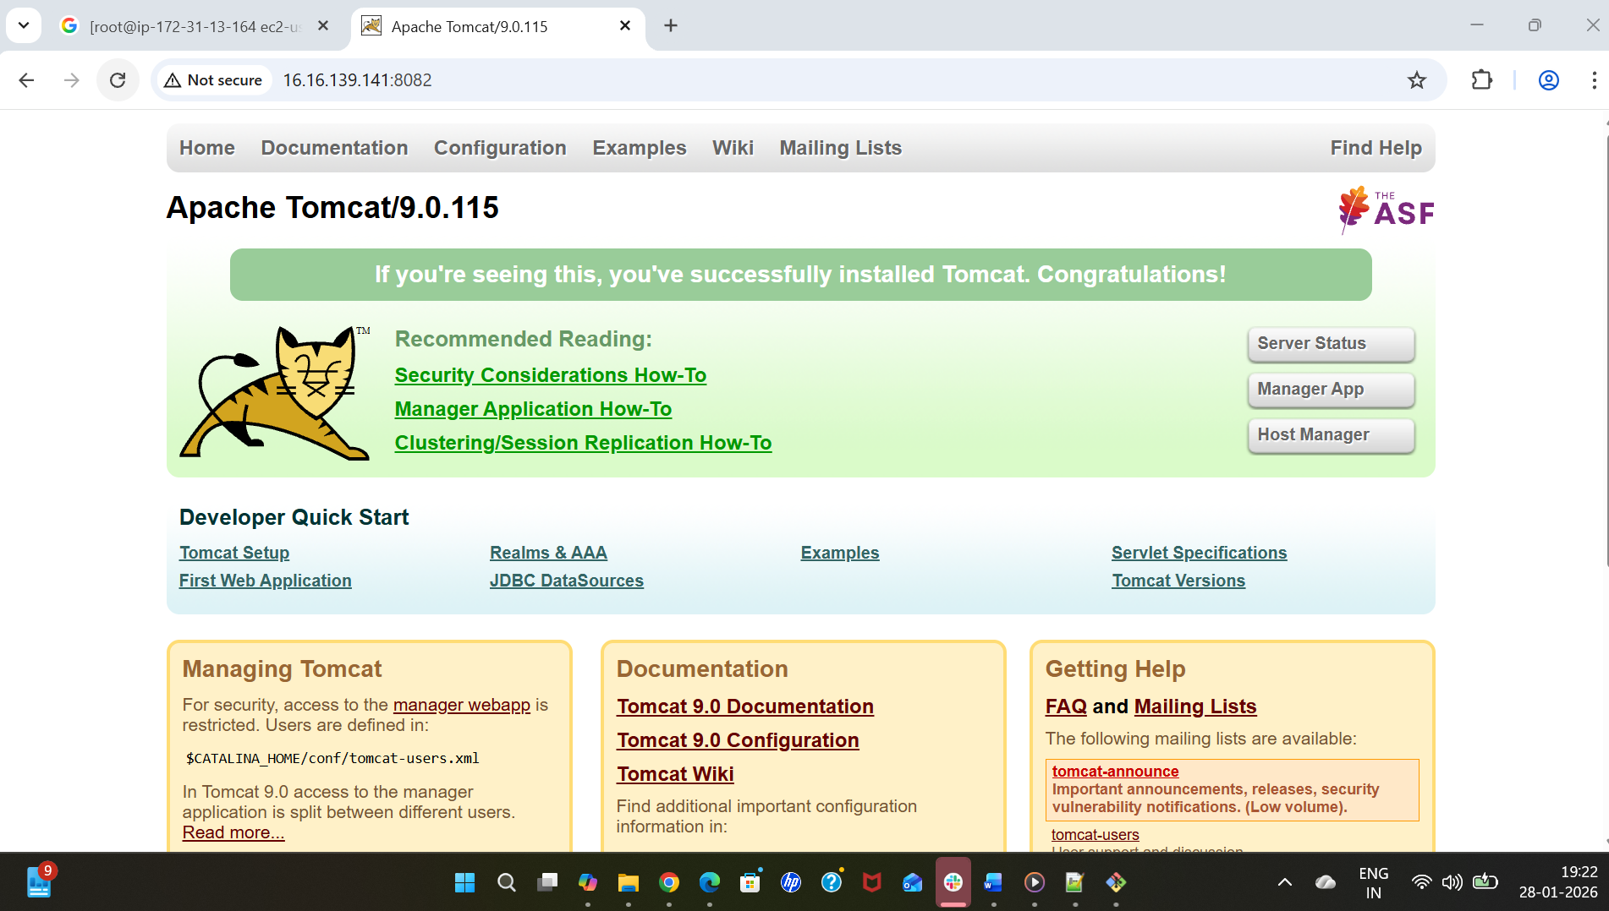

- Deploy a sample app on webapps
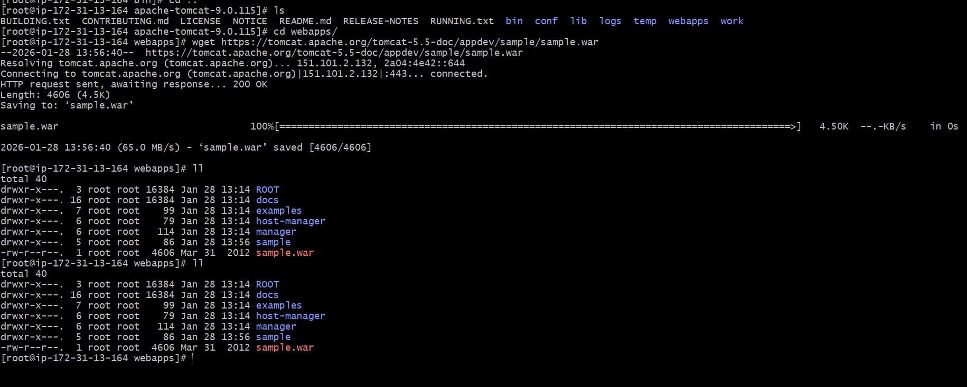
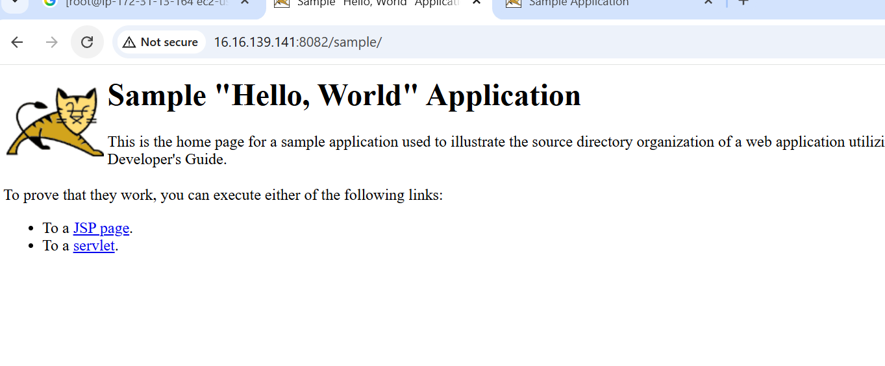
- Create a tomcat. Service file for tomcat.
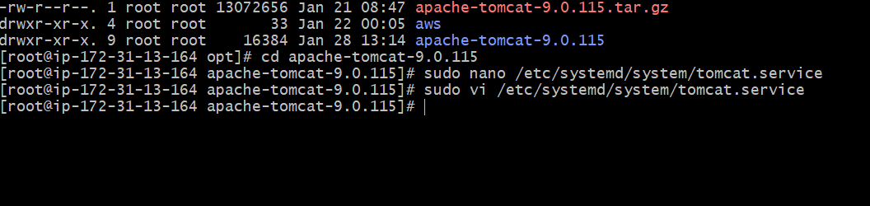
Copy the same in the above file
[Unit]
Description=Apache Tomcat 9
After=network.target
[Service]
Type=simple
Environment="JAVA_HOME=/usr/lib/jvm/java-1.8.0-amazon-corretto.x86_64"
Environment="CATALINA_HOME=/root/apache-tomcat-9.0.115"
Environment="CATALINA_BASE=/root/apache-tomcat-9.0.115"
ExecStart=/root/apache-tomcat-9.0.115/bin/catalina.sh run
ExecStop=/root/apache-tomcat-9.0.115/bin/catalina.sh stop
User=root
Group=root
Restart=on-failure
RestartSec=5
[Install]
WantedBy=multi-user.target
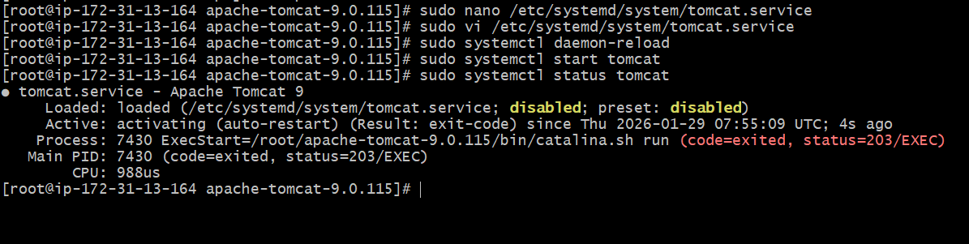

- Configure HA Proxy server

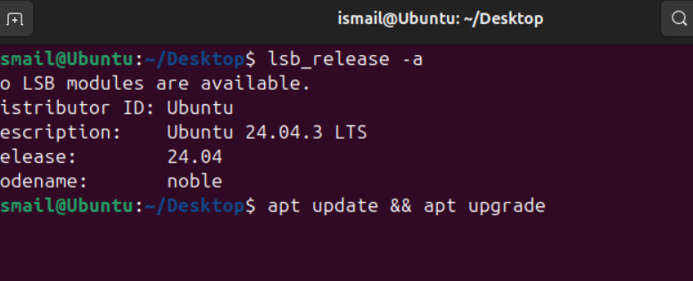
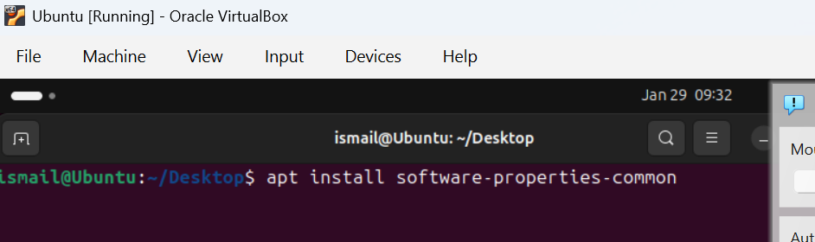
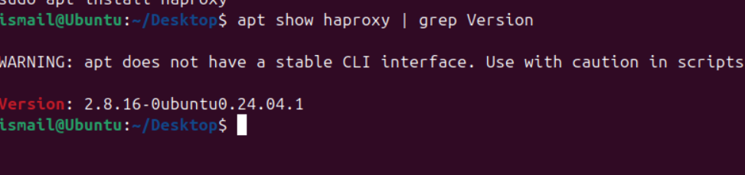
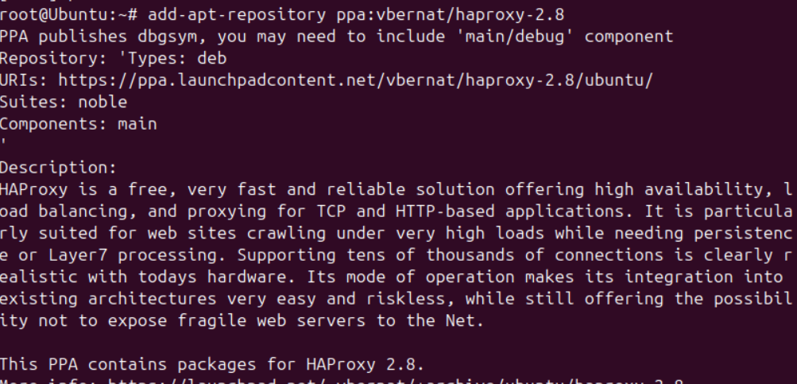
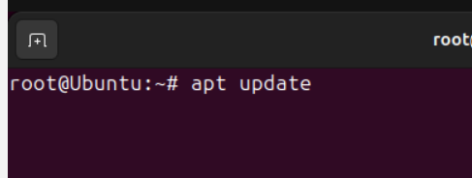

To Configure HAproxy
